Zachary Morrison, September 17th 2024

Zachary Morrison

NorQuest College   

The Role of AI in Modern Healthcare

Contents

The Role of AI in Modern Healthcare 1

Introduction 1

Source 1 (‘Transforming Healthcare’) 1

Source 2 (BMC Medical Education) 1

Source 3 (“Journal Of Korean Medical Science”) 2

Benefits of AI in Healthcare 2

# 

# 

# Introduction

AI (Artificial Intelligence) is by far the strongest technology used in modern healthcare today. It is growing very quickly regarding growing availability of healthcare medical data while having the advances of big data diagnostic techniques has finished the potential of the present fruitful use of AI. The modern use of healthcare technology has grown to many pioneering startups on the planet, which leads to humans living healthier/longer lives.

Datta, S., Barua, R., & Das, J. (2019). Application of artificial intelligence in modern healthcare system. *Alginates-recent uses of this natural polymer*.

## Source 1 (‘Transforming Healthcare’)

Health care is changing due to the presence of AI in modern health care and there is collaboration between AI developers and modern health care providers as this is imperative. Personalized medicine, clinical decision support systems, healthcare process optimization, patient engagement, and ethical considerations are all the areas in the healthcare system that AI developers and healthcare providers are working on. data analysis, pattern recognition, and predictive modeling are the main areas that AI developers will be providing support for in the healthcare system. To add, diagnosis and therapy are also big areas where AI will improve in the system. Integrating AI algorithms with patient data will lead to improved diagnosis precision and recognize health issues earlier on in life for the patient. Obviously, the outcomes of all of this will lead to a much more improved health care system by leading patients to healthier bodies/minds.

Patil, S., & Shankar, H. (2023). Transforming healthcare: harnessing the power of AI in the modern era. *International Journal of Multidisciplinary Sciences and Arts*, *2*(1), 60-70.

## Source 2 (BMC Medical Education)

AI’s key role in healthcare will be improving illness diagnosis, better treatment selection and clinical laboratory testing. AI’s ability to recognize patterns leads to better performance than humans in improving many healthcare aspects such as increased accuracy, reduced costs, and time savings while lowering mistakes made by humans. AI will improve general medicine, improve medication doses, provide virtual health assistants and improve mental health treatment. Overall decision-making for health care workers will be much easier due to AI in modern healthcare.

 Alowais, S. A., Alghamdi, S. S., Alsuhebany, N., Alqahtani, T., Alshaya, A. I., Almohareb, S. N., ... & Albekairy, A. M. (2023). Revolutionizing healthcare: the role of artificial intelligence in clinical practice. *BMC medical education*, *23*(1), 689.

## Source 3 (“Journal Of Korean Medical Science”)

Medical technology will be much improved due to AI in healthcare. Accurate diagnosis, identifying patient illness, and predicting where diseases will lead by using improved medical data. Improved medical technology will also lead to improved decision making and much better health results for patients. Unfortunately, there are present issues due to the presence of AI relating to privacy, reliability, safety, and liability. For AI to be more used in health care people must be more familiar with AI, standardized guidelines must be made, and technological advancements must be created.

Park, C. W., Seo, S. W., Kang, N., Ko, B., Choi, B. W., Park, C. M., ... & Yoon, H. J. (2020). Artificial intelligence in health care: current applications and issues. *Journal of Korean medical science*, *35*(42).

# Benefits of AI in Healthcare

|  |  |  |
| --- | --- | --- |
| Sooner discovery of illness | Better decision making | Improved help in treatment |
| Enhanced access to medical services | Improved patient experience | Customized medicine |
| New Drug revelations | Virtual nursing aids | Robot aided surgery |

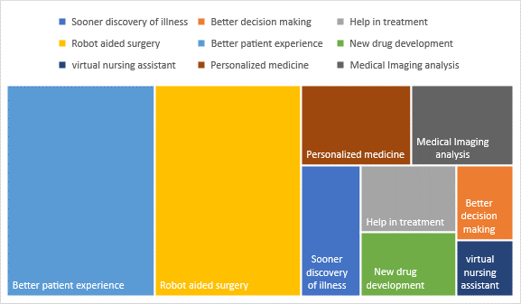

[The Role of Artificial Intelligence in Healthcare Management - futuresoftech.com](https://futuresoftech.com/the-role-of-artificial-intelligence-in-healthcare-management/)

# References

* Datta, S., Barua, R., & Das, J. (2019). Application of artificial intelligence in modern healthcare system. *Alginates-recent uses of this natural polymer*.
* Patil, S., & Shankar, H. (2023). Transforming healthcare: harnessing the power of AI in the modern era. *International Journal of Multidisciplinary Sciences and Arts*, *2*(1), 60-70.
* Alowais, S. A., Alghamdi, S. S., Alsuhebany, N., Alqahtani, T., Alshaya, A. I., Almohareb, S. N., ... & Albekairy, A. M. (2023). Revolutionizing healthcare: the role of artificial intelligence in clinical practice. *BMC medical education*, *23*(1), 689.
* Park, C. W., Seo, S. W., Kang, N., Ko, B., Choi, B. W., Park, C. M., ... & Yoon, H. J. (2020). Artificial intelligence in health care: current applications and issues. *Journal of Korean medical science*, *35*(42).